USING A CREDIT FOR ONE RJO VENDOR ON ANOTHER RJO VENDOR’S BILL

The RJO organization allows a store to pay one vendor but use another vendor’s credit to lower your payment in total to RJO Corporation. They can do this because you make your payment to RJO not any vendor.

QuickBooks does not allow you to use one vendor’s credit to pay another. So we have a work around. We will have to make one journal entries to move the credit from one vendor the RJO Exchange account. In your QuickBooks file I have saved one journal entry.

- Your report will show if a vendor with an outstanding credit balance.
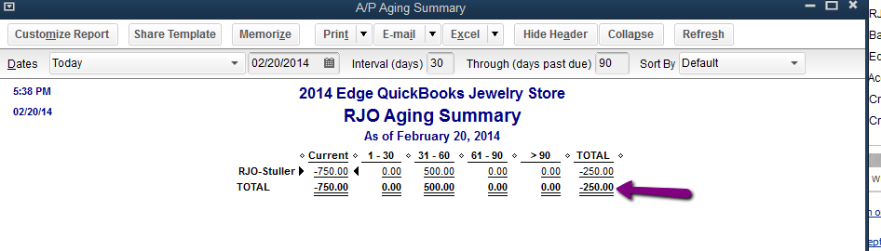
- Go to your memorized Transaction (Control+T) and pull up the “Use Credit to Pay RJO”.
- On the first line in the name field choose the RJO vendor you want to take away their credit. Fill in the amount of credit in the fields denotes in instructions on the form:
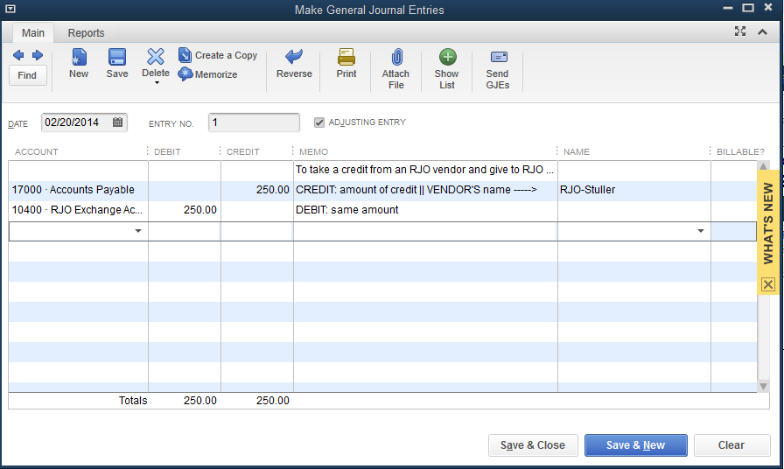
- Now that credit has been taken away from that vendor and given to the RJO Corporation in the RJO Exchange account
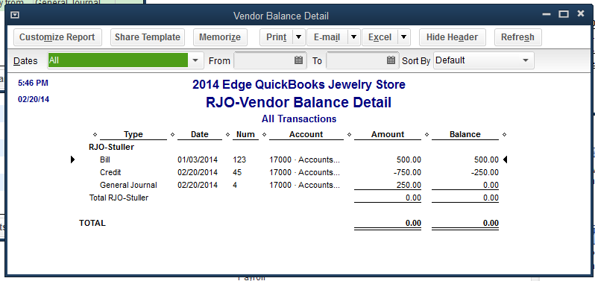
- We still need to apply the remaining credit left over to the vendors bill (in this case: Stuller) to make them truly zero. We want the bill and matching credit to now disappear.
- Go to PAY BILLS, click on RJO-Stuller and you will apply the credit and then click PAY BILLS. It will pay off the bill without spending any “money”.
Click on the second Stuller Bill, this gets paid off as well and what's left is the credit left in the RJO exchange account.
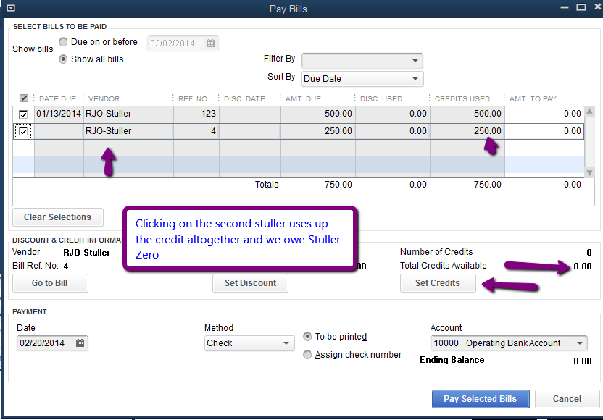
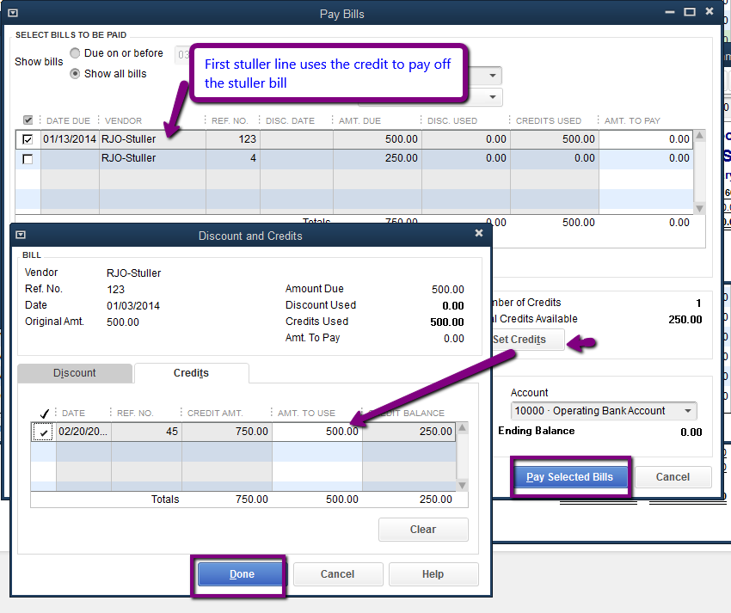

- Now if we look in the RJO Exchange account and we have used the $250 credit from Stuller to lower complete RJO debt.
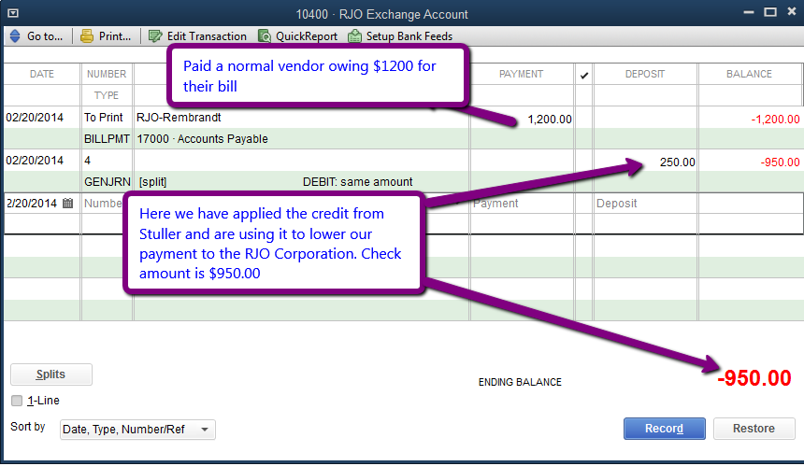
- If we look at our Account payables because we went to “Pay Bills” Stuller is paid and not even shown:
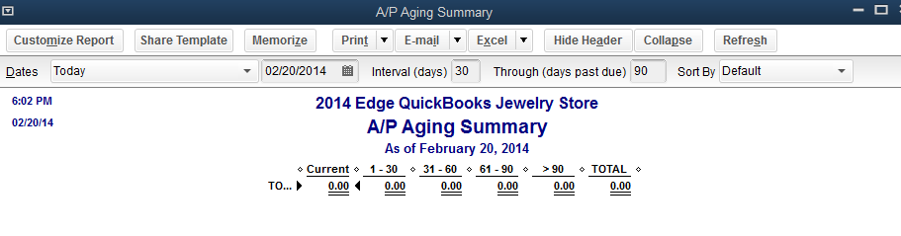
- No you can see the RJO Exchange account is lower than what we owe RJO because of ‘taking the credit” from the vendor and giving it to RJO.

